This file contains the information about how to run the code, what would be the possible inputs and outputs.

1. **How run code:**

Navigate to the src directory containing the Python files and compile them using the following commands:

- Python Hashing.py

- Python Heapsort.py

- Python MenuGraph.py

- Python SortingAlgoComparison.py

1. **How to give Input and get the output:**

MenuGraph.py

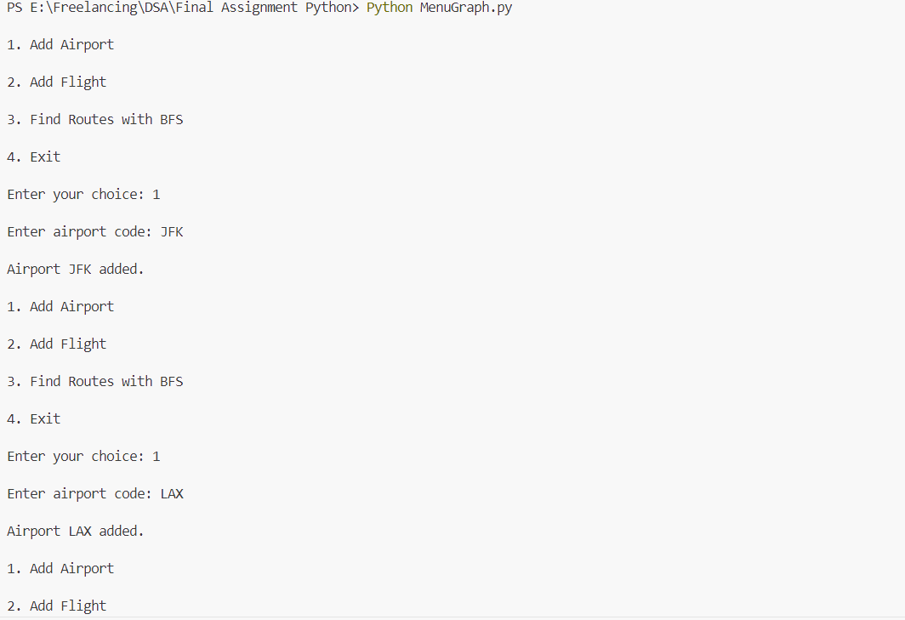

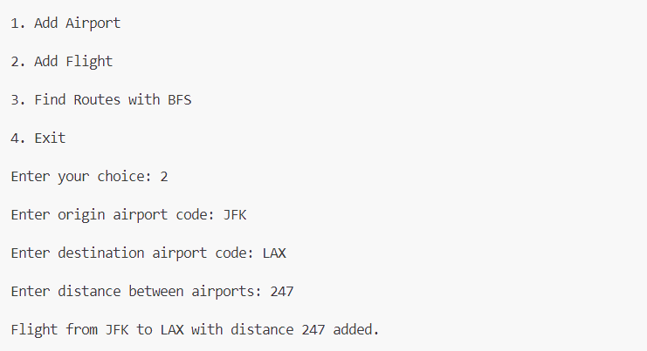

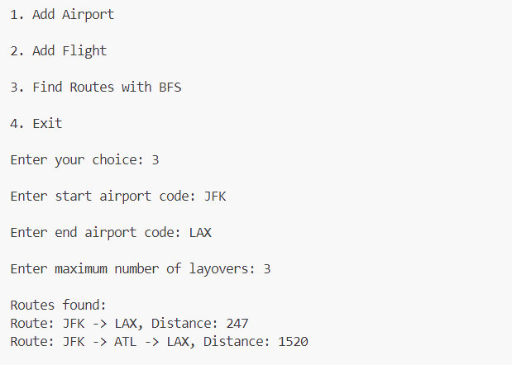

Hashing.py

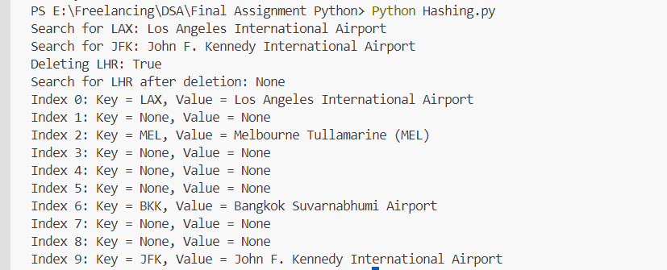

HeapSort.py

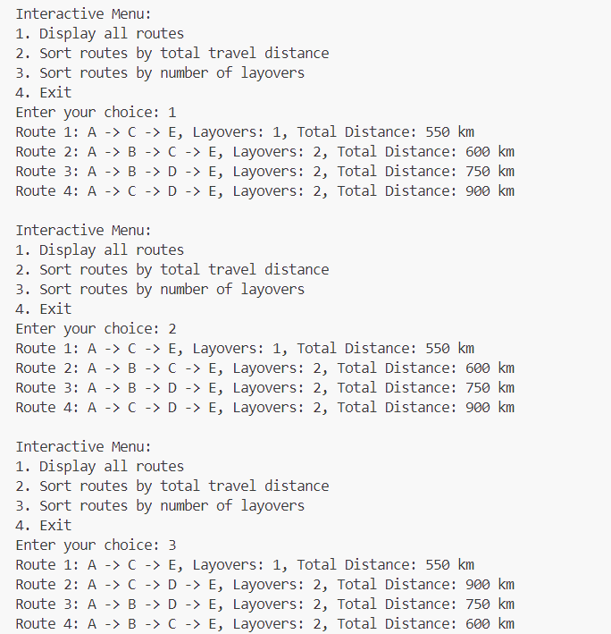

SortingAlgoComparison.py

